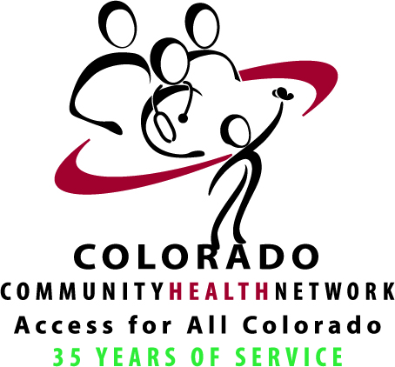
CCHN Health Care Advocate Program Application

Instructions

Program Overview and Goals
The Health Care Advocate Training Program (HCA), a one-of-a-kind program, blends leadership development and advocacy training in an experiential learning environment. Participants will be provided with a set of defined leadership and advocacy skills as well as needed health care policy information and context that will allow them to become impactful advocates for change. Participants will also have opportunities to network with and learn from local, state, and national health care experts along with legislators working for our communities.

The goal of the program is to bring the highly respected voice of the health care provider to the table to help inform and influence health care policy impacting Coloradans.

Visit http://cchn.org/emerging-health-care-advocacy-program/ for more details.

Application Process
Please complete all sections on this form and direct via email attachment to Kim Moyer at kmoyer@cchn.org

Executive Aggreement of Support
Interested Community Health Center (CHC) clinician applicants will need support from executive leadership (CMO, CDO, Clinic Director, HR Director, CEO, etc.). CHC executives can also nominate clinician applicants who are passionate about the CHC model of care and have a desire to hone their leadership and advocacy skills.

Supporting executives agree to:
- Work with the participant on schedules so that they can attend all in person sessions,
- Attend the morning session on April 28, 2018 (9a-1p) in order to understand the goals of the program and to learn how they can support their clinician’s success in the program, and
- Attend the 4-hour celebration in February, 2019 to see the results of the particiants’ capstone projects.

Personal Statement
In the space provided, applicants shall describe their commitment to the goals of the HCA program and how they will utilize their new leadership and advocacy skills to advance the health of their community, region, and/or state.

Applicant Obligation Statement
All applicants must commit to the 13-month long training program and attend all training workshops including: four in-person training and networking workshops, seven remote webinars, six telephonic coaching sessions, and the capstone celebration. Find a listing of detailed dates and more program information here: http://cchn.org/emerging-health-care-advocacy-program/. By submitting this application, the applicant is agreeing to the above.

Applicant/Nominee Information
CHC Name: |  | Site Name:
Nominee Name: |  | Job Title:
CHC Address: |  | City State, Zip:
E-Mail Address: |  | Phone/Extension:

Executive Agreement of Support
CHC Name: |  | Clinic Site Name:
Executive Name: |  | Job Title:
CHC Address: |  | City State, Zip:
E-Mail Address: |  | Phone/Extension:
Please briefly explain why this individual would be a good candidate for the HCA program.

I agree to support _______________________ throughout the HCA program, including working with their schedule so they can be at all in person trainings, attending the first in-person session, and attending the capstone celebration in February 2019.

Executive Signature: __________________________________ Date: _______________________

Personal Statement
Applicants shall describe their commitment to the goals of the HCA program and how they will utilize their new leadership and advocacy skills to advance the health of their community (Max 500 words).

Email all application documents to Kim Moyer at kmoyer@cchn.org by close of business,
Wednesday January 10, 2018

